Flight Path: AI-Powered Assessment
and Personalized Recommendation

A System Plan Proposal Submitted to the Faculty
of the School of Computing and Information Technologies
Asia Pacific College, Makati City

In Partial Fulfillment of the Requirements of the subject
Introduction to Systems and Design for IT
SSYADD1

By
Justin Bryden G. Arroco | Don Victor L. Idos
John Michael O. Maala | Andrei Luis M. Torres
Adviser: Manuel L. Calimlim, Jr.
Consultant: Felino Calderon

I. Design Thinking

Stage 1 – Empathize:
Introduction
The first step of the design thinking process is to build empathy and develop a deep understanding of the people for whom we are designing the solution. For the “Flight Path” project, this meant engaging closely with the client, UpsWing!, to uncover their real needs, frustrations, and aspirations beyond what was written in initial project requirements. Our goal in this stage was not only to learn what they say they need, but also to understand what they do, think, and feel when navigating their current assessment process.
To accomplish this, our team conducted a series of interactions that served as in-depth client interviews. The first formal meeting was held through Google Meet with the UpsWing! CEO and representatives. During this session, we explored their current ESL assessment process, discussed its limitations, and aligned on the broader objectives of the project. The client emphasized recurring challenges such as inefficiency, reliance on manual evaluations, and scalability issues. They also stressed their commitment to academic rigor by referencing their use of CEFR standards, item analysis, and inter-rater reliability checks. This meeting set the foundation for understanding that the problem was not simply technical but also organizational and educational in nature.
Beyond the initial interview, our team also maintained direct chat conversations with the client. These discussions became a valuable channel for clarifying requirements, addressing changes, and confirming expectations in real time. This iterative exchange ensured that our understanding of the client’s pain points and goals remained aligned with their evolving needs.
Through these engagements, we not only documented the client’s processes but also began to empathize with the different personas involved: learners frustrated by slow placement, parents seeking clear reports before making payment decisions, tutors burdened by manual evaluations, and administrators struggling with operational bottlenecks. These insights highlighted the human side of the problem and provided the foundation for framing the root cause and defining what a successful solution should look like.

Client Interviews

To better understand the needs and challenges of the client, our team conducted a series of interviews and follow-up discussions with UpsWing!’s CEO and representatives. These interactions were carried out through both formal and informal channels, enabling us to gain a holistic perspective of the current ESL assessment process.
The first formal interview took place via Google Meet. This session allowed us to explore the existing placement and diagnostic system in detail. The client explained that their current process relies heavily on coordinators and admins, which makes it time-consuming, inconsistent, and difficult to scale as enrollment grows. They emphasized that while efficiency is important, the solution must also uphold academic rigor, citing their reliance on CEFR standards, item analysis, and inter-rater reliability checks to maintain validity.
In addition to the formal meeting, we also engaged in direct chat conversations with the client through messaging platforms. These follow-up discussions were crucial for clarifying requirements, confirming project scope, and addressing updates or changes the client wanted to make as the project progressed. These exchanges gave us real-time insights into their expectations, such as the importance of distinguishing between adaptive placement tests and non-adaptive diagnostic tests, and their interest in integrating AI-driven speaking assessments.
From these interviews, several recurring themes emerged:
- Inefficiency: Current manual processes delay student evaluation and learning ath assignment, frustrating students.
- Scalability issues: Reliance on coordinators and tutors creates bottlenecks as student numbers grow.
- Consistency and rigor: The system must ensure reliable, CEFR-aligned assessment results.
- Stakeholder impact: Tutors and admins face heavy workloads, while students and parents risk mismatched placements.

FIGURE I: ONLINE GOOGLE MEET MEETING WITH UPSWING!
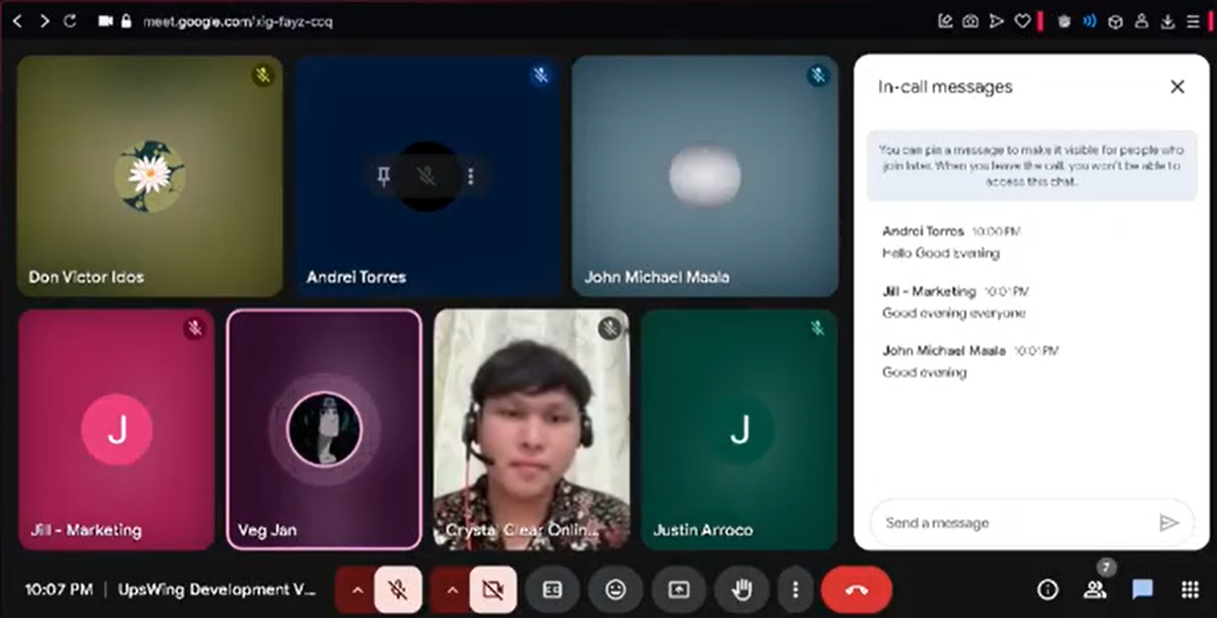

"5 Whys" Analysis (Identified Root Cause)
Analyzing the client’s statements revealed the underlying cause driving this project.

Problem: UpsWing! needs to automate its assessment process.
- Why #1? The process is slow.
- Why #2? Because it is done manually.
- Why #3? Because tutors must handle each assessment by hand, and they cannot keep up with the number of new requests.
- Why #4? (Root Cause) Because there is no existing automated system in place to support or replace the manual work.

Identified Customer Personas
FIGURE II: Empathy Map
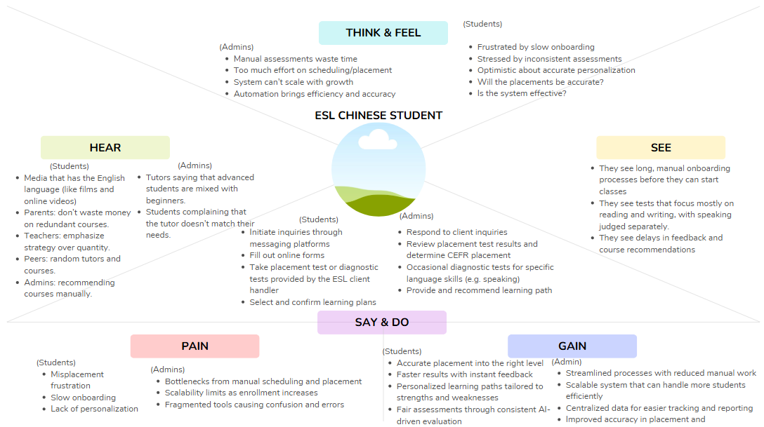

The interviews and discussions also highlighted the following key user groups whose needs and pains must be addressed:
- Students – The end-user who takes the tests. Their experience is central to the project’s goal of improving engagement. A fast, accurate placement process is essential to their motivation and success.
- Admins – An internal user responsible for managing onboarding and assessment workflows. Their pain points include repetitive manual tasks, bottlenecks, and coordination issues that slow down operations.
- Tutors – Another internal user who plays a role in evaluating students and conducting trial classes. Their involvement in manual evaluation represents a significant labor cost and introduces subjectivity that the new system aims to minimize.

Key Open-Ended Questions
- What is the core problem with the current system?
Answer: The current system is manual, labor-intensive, and inconsistent. It is too slow to scale with growing demand and often fails to accurately place students, leading to frustration and poor engagement.
- What does a successful solution look like?
Answer: Success is an automated system that delivers a computer adaptive placement (CAT) test for reading and listening, combined with AI-scored assessments for speaking and writing. This system should provide instant, accurate, CEFR-aligned results that guide learners into personalized learning paths.
- What are the most important constraints and requirements?
Answer: The solution must function as a backend system that can integrate into the client’s existing platform. It must clearly distinguish between adaptive placement tests and non-adaptive diagnostic tests, as this distinction is critical to the client’s process.

Q&A Session with Client – UpsWing!
This session took place in a discord conversation.

Format: Q&A for Clarifications
- Q1. How is the accuracy of assessment tests usually evaluated in the company’s processes? What frameworks (e.g., CEFR, IELTS standards) are you aligning with?
A1. UpsWing evaluates accuracy through CEFR-aligned diagnostic rubrics across listening, speaking, reading, and writing (Pre-A1 to C2). Tests may also include IELTS-style tasks for comparability. Accuracy is ensured by:
- Conducting item analysis (difficulty index, distractor effectiveness)
- Performing inter-rater reliability checks for speaking/writing rubrics
- Running pilot assessments before rollout
- Aligning benchmarks with CEFR Companion Volume and academic references (Cambridge, ALTE, etc.)

- Q2. Regarding the criteria or algorithms for matching students with tutors, what factors are considered?
A2. The matching algorithm is multi-criteria, factoring in:
- Student learning goals (Academic, Exam, Social, Career)
- Preferred availability and time zone compatibility
- Tutor experience and skill level (e.g., CEFR calibration, specialization)
- Tutor-student continuity preference (rapport building)
- Student learning profile data (diagnostics, past engagement style)
Note: Learning styles may be considered in future personalization phases.

- Q3. Is the system expected to have a “user feedback” functionality?
A3. Yes. Feedback is integrated at multiple levels, including:
- Tutor feedback forms after every class
- Parent reaction buttons on lesson reports
- Monthly parent satisfaction check-ins (via WeChat/LINE/email)
- AI sentiment analysis on open-ended feedback
- Automatic flagging of low scores for review

- Q4. Will there be formal surveys, interviews, or usage analytics?
A4. Yes. UpsWing applies triangulated feedback methods:
- Quarterly, pathway-based surveys for parents, learners, and tutors
- 1-on-1 interviews with parents/tutors (by HR or DSSI)
- Platform analytics (attendance rates, completion rates, reschedule frequency, dashboard engagement)
- Churn risk scoring from engagement/feedback data

- Q5. What is the current step-by-step ESL process at UpsWing!?
A5.
- Client Inquiry Handling – Contact via Messenger, WeChat, LINE, or website → Coordinator responds, explains program → Learner fills out online form → Briefing on diagnostic test.
- Placement Test & Analysis – Learner completes LMS diagnostic test → CEFR level evaluated → Academic team drafts recommendation.
- Trial Class Scheduling – Coordinator arranges 25-min trial → Materials sent via LMS → Tutor briefed.
- Trial Class Execution – Tutor conducts session → Learner participates in speaking activities → Tutor submits evaluation.
- Level Recommendation & Enrollment – Academic team finalizes CEFR placement → Parent selects plan/payment → Learner assigned tutor → Schedule confirmed.
- Class Delivery – Regular ClassIn sessions → Tutor uses LMS materials → Homework + AI-reviewed tasks.
- Feedback & Reporting – Tutor submits post-class feedback → Progress tracked in LMS → Monthly bilingual reports sent to parents.

- Q6. How will speaking and writing assessments work?
A6.
- Pronunciation Test: Students read aloud sentences/paragraphs. Evaluates clarity, stress, intonation, vowel/consonant accuracy.
- Speaking Test: Topic prompts/role-play. Evaluates fluency, coherence, vocabulary, grammar, communicative effectiveness.
- Writing Test: Constructed responses (reports, reflections). Evaluated with AI scoring aligned to CEFR rubrics.

- Q7. Which tests will be adaptive vs. non-adaptive?
A7.
- Placement Test: Adaptive (CAT, multiple choice with audio playback) – used to determine CEFR level.
- Diagnostic Tests: Non-adaptive – focused on specific skill gaps after lessons. Includes speaking/writing AI evaluations and non-adaptive multiple-choice for reading/listening.
- Summary: Placement = adaptive CEFR test. Diagnostics = non-adaptive gap analysis for personalized recommendations.

Insights Summary
The empathize stage confirmed that UpsWing!’s challenge goes beyond inefficiency; the deeper issue is that manual and inconsistent assessment processes lead to inaccurate placement, which in turn causes poor student engagement, dissatisfaction, and eventual churn. While efficiency and scalability are pressing business needs, the client emphasized that any solution must also preserve academic rigor and CEFR alignment to maintain credibility and learner trust.
Through client interviews, root cause analysis, and persona identification, we gained a clearer view of the needs of learners, parents, tutors, and administrators. Each group experiences the shortcomings of the current system differently, but all are connected by the need for a faster, more accurate, and scalable placement process.
These insights provide a strong foundation for the next stage of the design thinking process—Define—where we will synthesize the findings into a clear problem statement and identify opportunities for innovation.

II. Project Charter
Flight Path: AI-Powered Assessment and Personalized Recommendation
Purpose:
The Flight Path project was created to modernize and improve the English as a Second Language (ESL) assessment and placement process at UpsWing!, an ESL education provider. Currently, their processes rely on time-consuming, manual evaluations that often result in inconsistent placement decisions. Our goal is to solve these problems by introducing an AI-powered assessment system with adaptive and non-adaptive testing capability and personalized learning path recommendations. This will ensure that their onboarding and evaluation processes are faster, more accurate skill profiling, and tailored learning experiences that align with each learner’s goals and proficiency level.

High-level project description
Flight Path is a modular backend system designed for integration with UpsWing!’s existing platform. It will include the ff:
- Assessment Module that are adaptive and non-adaptive. The adaptive tests will be based on psychometric models such as MIRT, for precise CEFR-aligned placement and non-adaptive tests will include more specific language skill evaluation such as voice-based speaking assessments.
- Recommendation Engine that generates personalized learning paths based on the evaluation results.
- Administrative Tools for managing item banks, exporting reports, and monitoring assessment performance.
This system will be API-ready, allowing seamless integration with UpsWing!’s system while maintaining flexibility for future expansion.

High-level milestone schedule

TABLE I: HIGH-LEVEL MILESTONE SCHEDULE
Milestone | Estimated Week
Started Project Planning and Discovery, and Gathering of High-level Client Requirements | Apr 28 – May 11
User Research & Problem Definition Completed | May 12 – Jul 13
Finalization of Overall Project Requirements and Planning | Aug 4 – Aug 24
Finalization of System Architecture and API specs | Sep 8 – Sep 21
Development of Adaptive Test Delivery Engine (includes prototype demonstration and iterative feedback gathering) | Sep 22 – Oct 26
Development of Non-Adaptive Diagnostic Tests for Specific Language Skills Evaluation (includes prototype demonstration and iterative feedback gathering) | Oct 27 – Nov 16
Implementation of Recommendation Engine (includes prototype demonstration and iterative feedback gathering) | Nov 17 – Dec 7
API Development of the Whole Backend module | Dec 7 – Jan 11
Internal Testing and Quality Assurance | Jan 12 - 18
Pilot Testing with Upswing Client | Jan 19 – Jan 25
Finalize Feedback Gathering and System Refinement | Jan 26 – Feb 8
Final Testing, Optimization, and Documentation | Feb 9 – Feb 14
Final Delivery and Project Closure | Feb 15 – Feb 25

Rough cost estimate
The total estimate is ₱102,200.00. This comprehensive budget is allocated to cover all anticipated expenses required to meet the project objectives, including labor, materials, and administrative overhead.
The budget is broken down into two primary categories:
Planned Labor Costs: ₱61,000.00. This covers an estimated 610 hours of work by the four-person project team, based on a standard rate of ₱100/hour.
Planned Material & Unit Costs: ₱41,200.00. This includes all non-labor expenses such as co-working space fees, software subscriptions, supplies, and a contingency reserve.
The budget is strategically allocated across the project lifecycle, with most resources dedicated to the Executing phase.
- Initiation Phase – ₱23,000.00
- Planning Phase – ₱24,000.00
- Executing Phase – ₱41,200.00
- Monitoring & Controlling Phase – ₱8,500.00
- Closing Phase – ₱5,500.00

Stakeholders
- Upswing! (Client / Organization) – Provides budget, approves major decisions, sets priorities and requirements, gives feedback and recommendations.
- Manuel L. Calimlim (Project Adviser) – Provides academic supervision and general project guidance.
- Felino Calderon (Project Consultant) – Guides technical implementation, design choices, and overall project recommendations.
- Tutors (Upswing ESL Department) – End users who provide feedback on CEFR placement accuracy and diagnostic fairness.
- Students (Upswing ESL Students) – Primary end users; provide feedback on learning path recommendations and fairness of placement results.
- W.A.S.D (Development Team, APC) – Core builders of the FlightPath system; ensure functionality meets academic and client standards.
- Admins (Upswing Academic/Operations Department) – Use diagnostic and placement tools, review results, and provide ongoing feedback.
- Instructor and School (Asia Pacific College, PBL Program) – Oversee project progress, academic compliance, and documentation quality.
- Testers – Evaluate usability, provide performance feedback, and verify system stability before deployment.

Project manager: Andrei Luis M. Torres, Project Leader
Project manager’s responsibilities:
- Oversee overall project coordination and lead team efforts.
- Ensure all documentation, written materials and deliverables are comprehensive and meet quality standards.
- Communicate with the project adviser on behalf of the team.
- Make sure the project is on track with the timeline.

Project manager’s authority
- Lead project meetings and presentations to the client and adviser.
- Assign tasks to the dev team members.
- Guide the project workflow
- Manage which tasks to be prioritized
- Make final decisions with team input

Formal declaration of sponsor’s support
Sponsor Name: Jose Eugenio L. Quesada
Position: Project-Based Learning Instructor

Support Statement:
As the instructor for the Project-Based Learning course, I support the FlightPath: AI-Powered Assessment and Personalized Recommendation project created by the student group. This project has the potential to modernize and improve the English as a Second Language (ESL) assessment and placement process for educational providers. It clearly demonstrates the students' ability to solve real-world problems through technology by addressing the inefficiencies of traditional evaluation methods. I encourage the group to complete this project with teamwork, effort, and creativity.

"Flight Path" Project Objectives
Primary Objective
Develop a modular, AI-assisted English language assessment and recommendation system to automate proficiency testing and generate personalized learning paths.

Specific Objectives
- Design and deploy an adaptive English assessment system within 6 months, achieving at least 90% accuracy in classifying learners according to CEFR levels.
- Integrate an AI-powered speaking assessment module that transcribes and scores learner responses, reducing manual evaluation time by at least 70%.
- Implement a data-driven recommendation engine within 4 months of system deployment, achieving at least 85% alignment with expert-curated recommendations.
- Deliver modular backend components, including the Adaptive Assessment Module, AI-Powered Speaking Assessment Module, Learner Recommendation Engine, and Administrative Utilities.

TABLE II: CATEGORIZED OBJECTIVE TABLE
Objective | Category | Measure
To design and deploy a modular, AI-assisted English language assessment and recommendation system for UpsWing! | Development | Delivery of modular backend components for an Adaptive Assessment Module, AI-Powered Speaking Assessment Module, Learner Recommendation Engine, and Administrative Utilities.
To design and deploy an adaptive English assessment system with at least 90% accuracy in classifying learners according to CEFR proficiency levels. | Accuracy | The system’s classification accuracy will be verified against expert validation and must be at least 90%.
To integrate an AI-powered speaking assessment module that reduces manual evaluation time by at least 70%. | Efficiency | The reduction in time for manual evaluation will be measured after the module’s integration and must be at least 70%.
To develop a data-driven recommendation engine that achieves at least 85% alignment with expert-curated recommendations. | Performance | Alignment with expert recommendations will be measured during pilot testing and must be at least 85%.
To develop a system that leverages psychometric models, transcribes and scores responses, and generates personalized learning paths. | Functionality | The system must include the core logic for a Computerized Adaptive Testing (CAT) system, AI-driven speaking assessment using APIs, and a recommendation engine.

Scope Statement
Project Goal and Objectives
The goal of the project is to develop a modular, AI-assisted English language assessment and recommendation system for UpsWing!. The system will automate proficiency testing and create personalized learning paths by accurately evaluating a learner’s skills.

Project Boundaries
Within scope: The project includes the research, design, and development of reusable, modular backend components. The deliverables will be API-ready or plug-in compatible for UpsWing!’s existing platform. It includes:
- Adaptive Assessment Module
- AI-Powered Speaking Assessment Module
- Learner Recommendation Engine
- Standard Setting and CEFR Alignment Tools
- Administrative Support Utilities

Out of scope: The project does not include integration of the developed modules into the client’s existing UI/UX, front-end, or data flows. This responsibility falls to the client-side developers. The project is limited to English assessments only and does not support multilingual handling. Front-end elements, UI components, and visualization of results are excluded.
Project Deliverables
  - Adaptive Assessment Module
  - AI-Powered Speaking Assessment Module
  - Learner Recommendation Engine
  - Standard Setting and CEFR Alignment Tools
  - Administrative Support Utilities
Success Criteria
  - The adaptive English assessment system will be designed and deployed within 6 months, using psychometric models to classify learners according to CEFR proficiency levels with at least 90% accuracy.
  - The AI-powered speaking assessment module will be integrated by the end of the development phase, transcribing and scoring responses with at least a 70% reduction in manual evaluation time.
  - The recommendation engine will be implemented within 4 months of the assessment system’s deployment, producing personalized learning paths with at least 85% alignment to expert-curated recommendations during pilot testing.

Project Assumptions
- A demo item bank will be delivered, but full calibration using real learner data must be completed by the client.
- Accuracy and performance of the speech evaluation module depend on the reliability of external APIs.
Project Constraints
- Reliance on third-party APIs for speech evaluation.
- Exclusion of multilingual support.
- Exclusion of front-end/UI development.
- Integration into the client’s existing system is the responsibility of the client-side developers.

Stakeholder Analysis

TABLE III: STAKEHOLDER ANALYSIS TABLE
Name | Department/Company | Position | Advisers | Objective, Requirements, Interests | Influence | Project Contribution | Resitance
Upswings | ESL Company | Organization/Client |  | Ensure project meets organizational goals and product quality. | High | Provides budget, approves major decisions, sets priorities and requirements, feedbacks and recommendations, and overall project information. | Concerns about scope and budget.
Manuel L. Calimlim  Jr. | Asia Pacific College | Project Adviser |  | Ensure project meets organizational goals and product quality. | High | Provides supervision and academic guidance, and general project recommendations. | Concerns about overall project quality.
Felino Calderon | Asia Pacific College | Project Consultant |  | Ensures project meets technical requirements and scope. | High | Guides technical implementation and design choices, and general project recommendations. | Concerns about overall project quality.
Tutors | Upswing | ESL Tutors | Upswing Academic Department | Requires fair and accurate CEFR placement and clear diagnostic feedback that aligns with course preparation. | Medium | End users, and provides feedback. | Concerns about system accuracy and fairness.
Students | Upswing | ESL Students |  | Requires fair and accurate CEFR placement and diagnostic feedback, and receive appropriate learning path recommendations. | High | End users, and provides feedback. | Concerns about their overall student experience including fairness and appropriateness of recommended learning paths.
WASD | Asia Pacific College | Development Team | Project Adviser, Project Consultant | Deliver a functional FlightPath system that meets project requirements, satisfies client needs, and aligns with academic standards. | High | Core builders of the system (FlightPath). | Time/resource constraints, project technicality, achievable project goals.
Admins | Upswing | Academic/Operation Department |  | Requires accurate placement and diagnostic results, and appropriate learning path recommendations. | High | End users, and provides feedbacks. | Inaccurate assessment system and recommendation engine.

IV. Diagrams

FIGURE III: USE CASE DIAGRAM
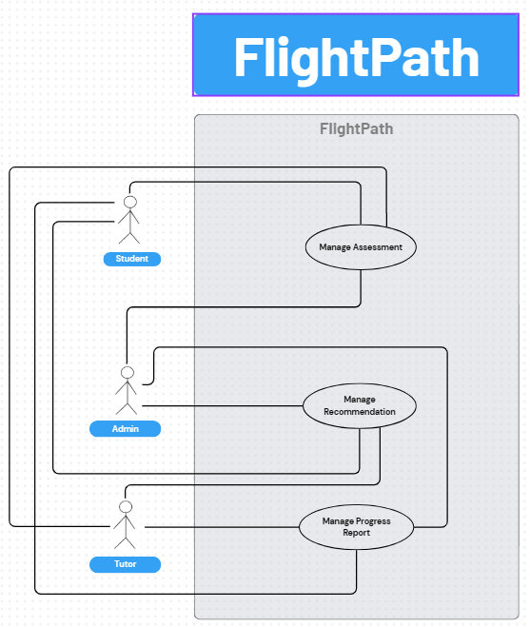

TABLE IV: TEST CASE TABLE
TC ID | UCID | Test Case Name | Test Case Description
TC-01 | UC-01 | Verify Create Assessment | Admin should be able to create a new assessment with complete details and save it successfully.
TC-02 | UC-0 | Verify Assign Assessment | Admin should be able to assign an existing active assessment to a student or a group of students.
TC-03 | UC-0 | Verify Perform Assessment | Student should be able to access, take, and complete assigned assessments (placement, writing, or speaking).
TC-04 | UC-0 | Verify Update Assessment | Admin should be able to modify assessment configurations and update existing items or settings.
TC-05 | UC-0 | Verify Archive Assessment | Admin should be able to archive an outdated assessment, preventing it from appearing in active lists.
TC-06 | UC-0 | Verify Review Assessment History | Students, tutors, and admins should be able to view a student’s past assessments and details.
TC-07 | UC-0 | Verify Export Assessment History | Students, tutors, and admins should be able to export a student's assessment history as a downloadable file (PDF/CSV).
TC-08 | UC-0 | Verify Generate Recommendation | System should automatically generate personalized course or tutor recommendations after assessment completion.
TC-09 | UC-0 | Verify View Recommendation | Students, tutors, and admins should be able to view generated recommendations for a student.
TC-10 | UC-10 | Verify Override Recommendation | Admin should be able to manually override or edit the system’s auto-generated recommendations.
TC-11 | UC-11 | Verify View Realtime Progress Report | Students, tutors, and admins should be able to view real-time analytics and progress tracking.
TC-12 | UC-12 | Verify Export Progress Report | Students, tutors, and admins should be able to export the progress report in PDF/CSV format.

FIGURE IV: DFD LEVEL 0
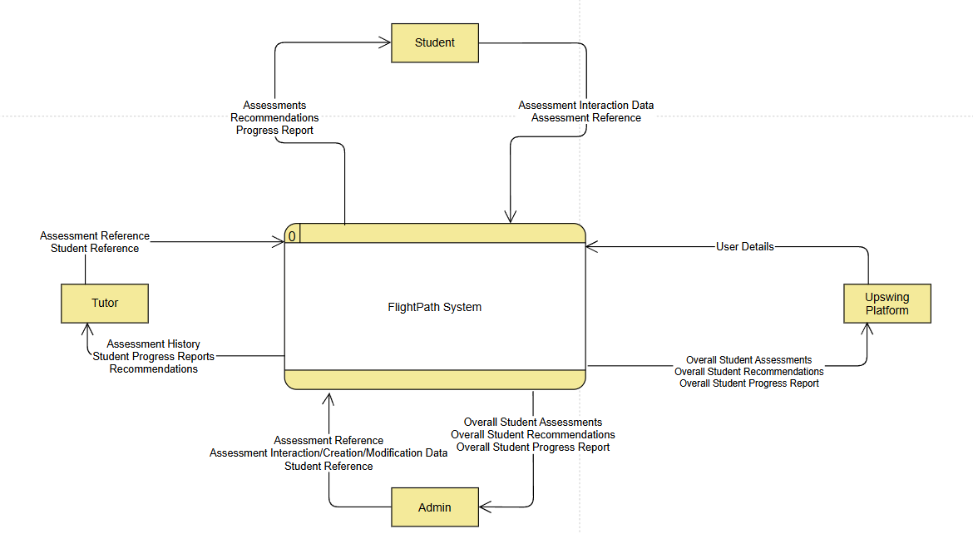
FIGURE V: DFD LEVEL 1
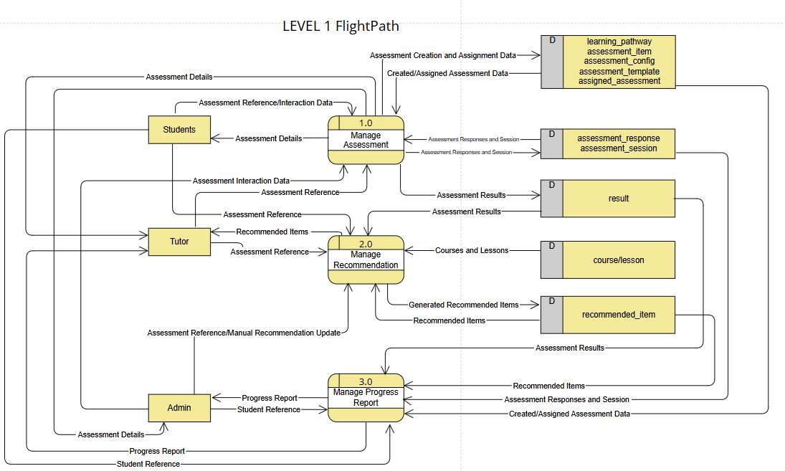

FIGURE VI: DFD LEVEL 2 – 1.0
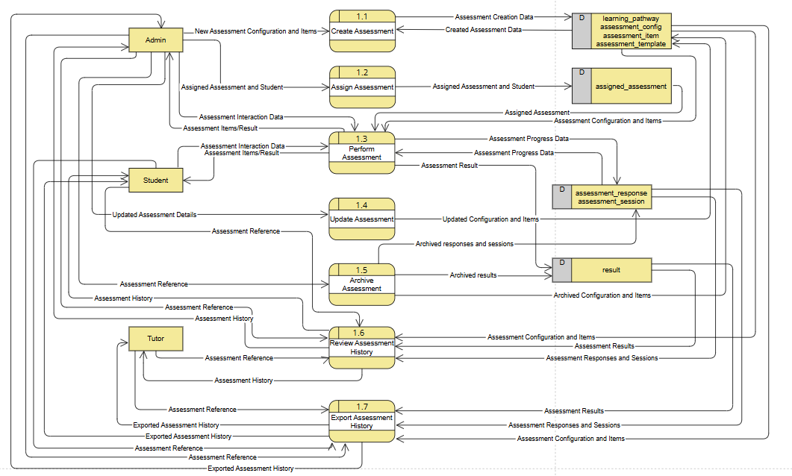
FIGURE VII: DFD LEVEL 2 – 2.0
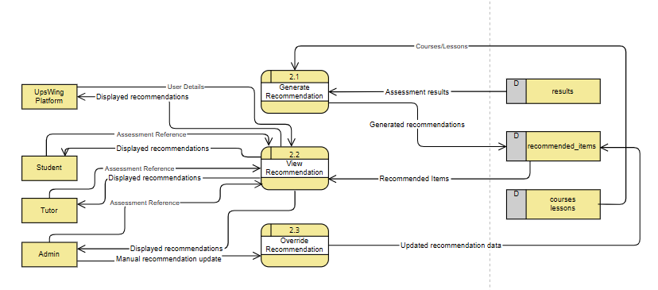

FIGURE VIII: DFD LEVEL 2 – 3.0
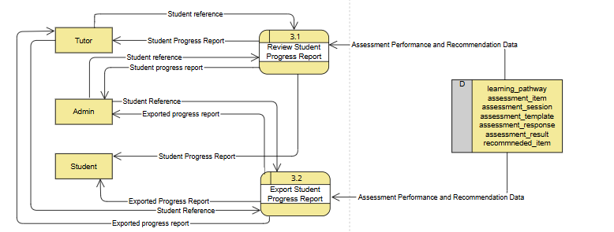

FIGURE IX: DFD LEVEL 3 – 1.3.x
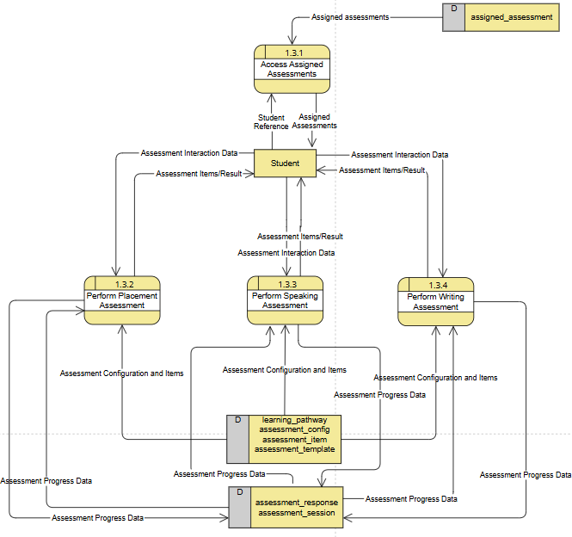

FIGURE X: DFD LEVEL 3 – 1.3.x
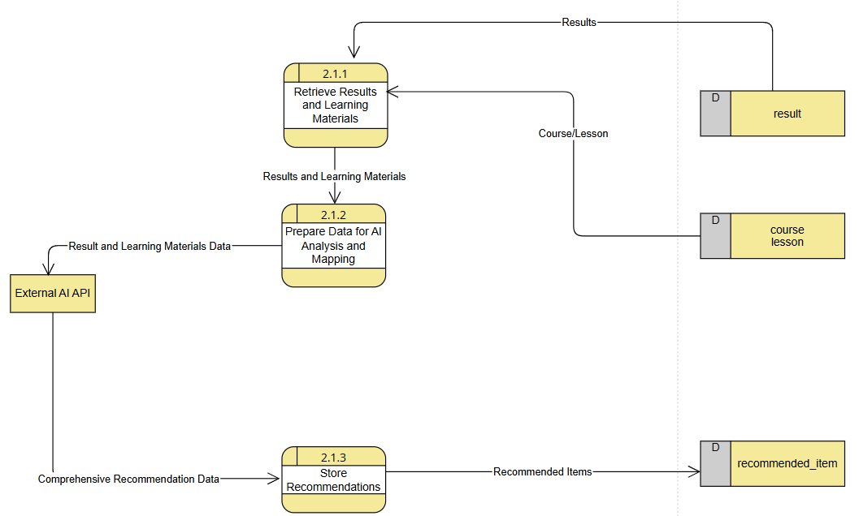

FIGURE XI: DFD LEVEL 4 – 1.3.2.x
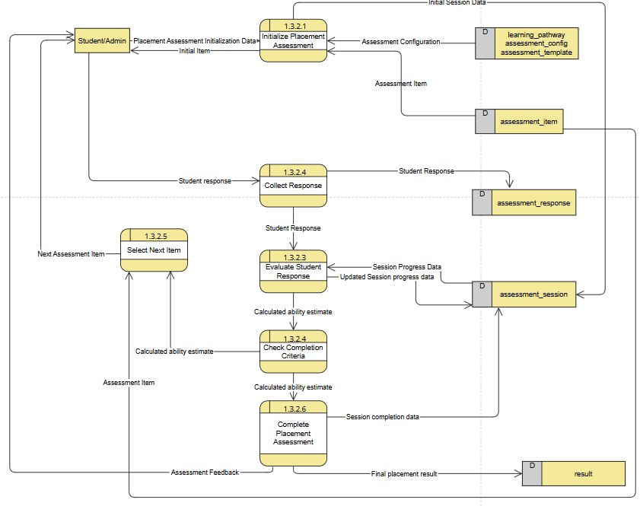

FIGURE XII: DFD LEVEL 4 – 1.3.3.x
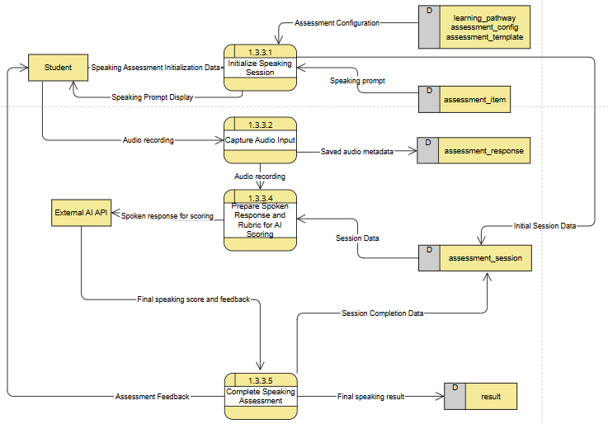

FIGURE XIII: DFD LEVEL 4 – 1.3.4.x
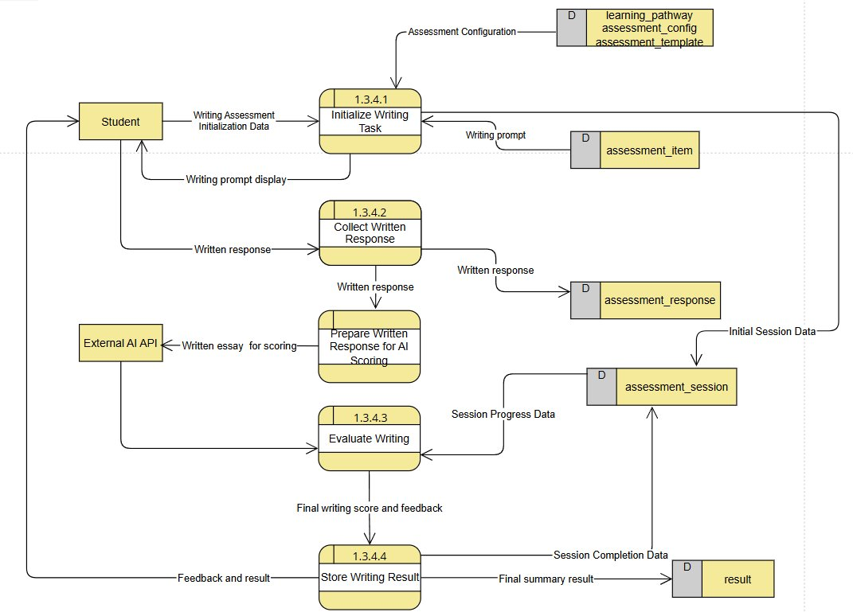

FIGURE XIV: ERD DIAGRAM
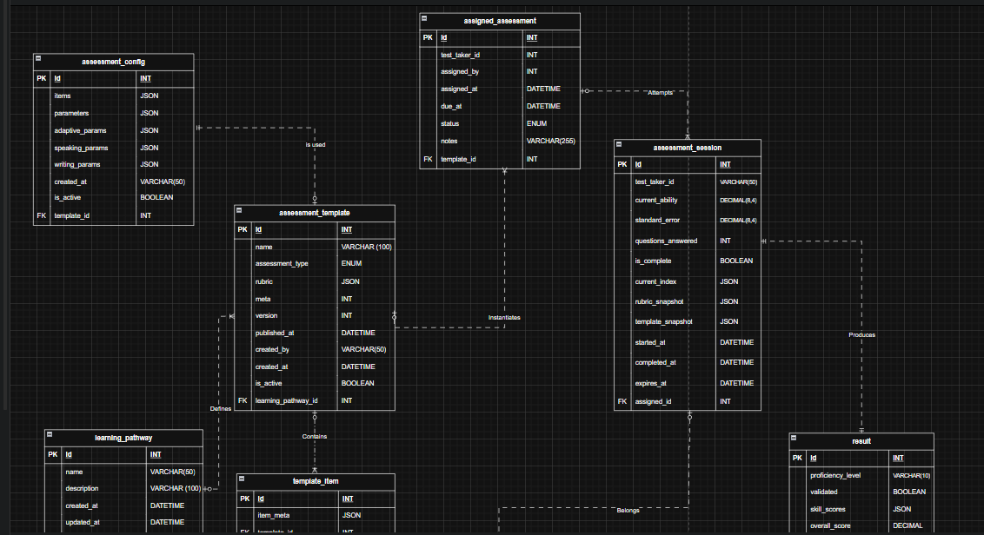
Link to ERD Diagram

FIGURE XV: ACTIVITY DIAGRAM
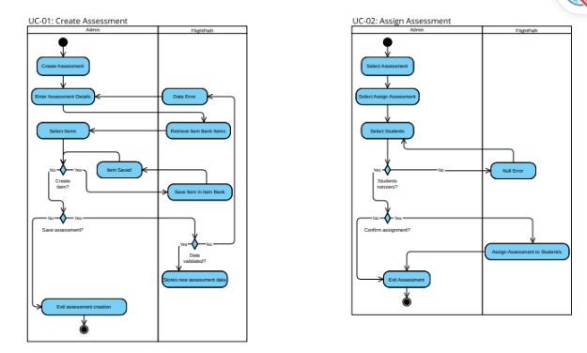
Activity Diagram Link

